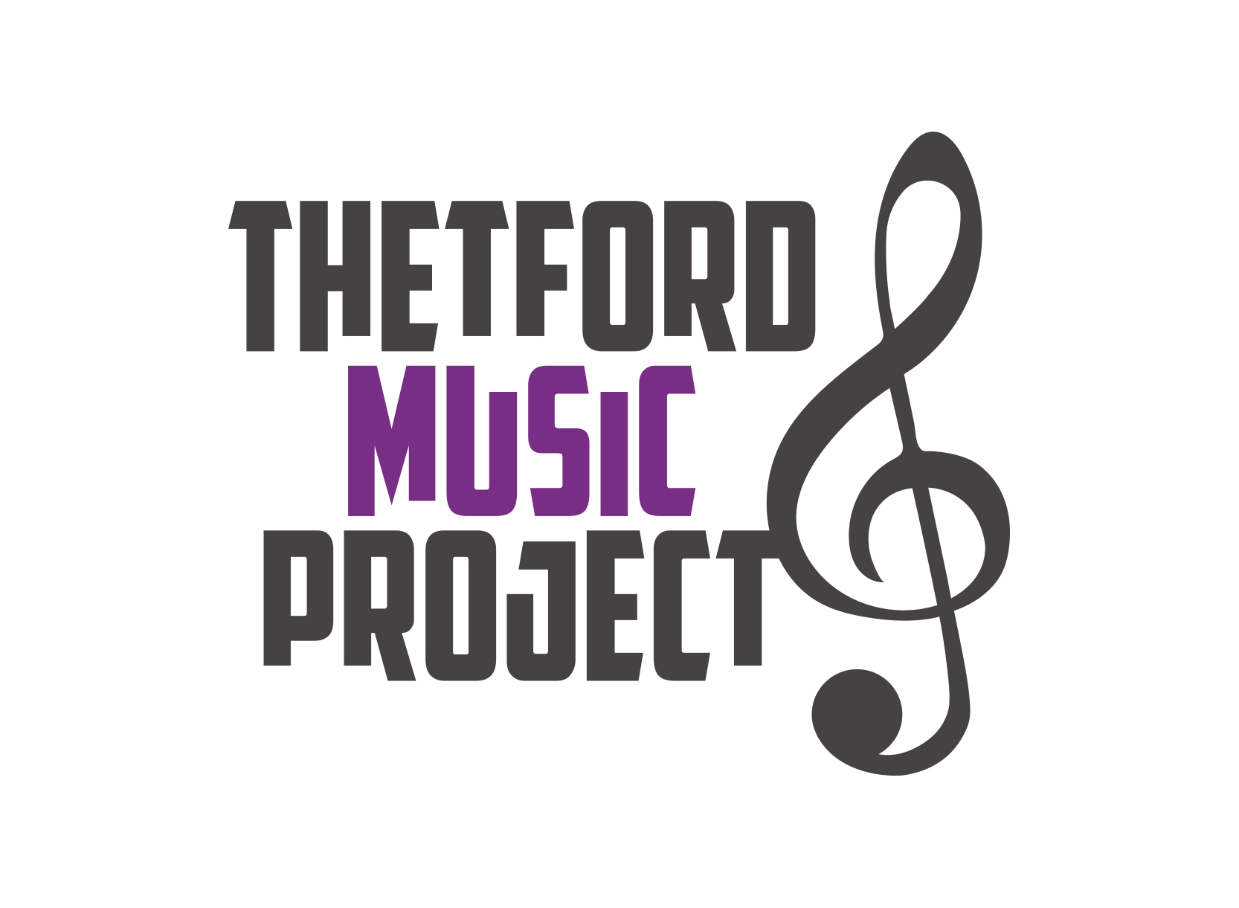
Music Course
CHILDREN
Thursday 08 August 2024 – Saturday 10 August 2024 
We would like to invite young musicians from all over Norfolk to attend our 3 day music course, giving them an opportunity to play various types of music of an Easy to Intermediate level and make new friends with children with a similar interest.
We hope to have swimming on the timetable and other activities, as well as playing lots of music! Staff members will be from Thetford Music Project alongside Parent Volunteers and our Musical Director will be Eddie Seales.
Parents, Friends and Relatives are invited to attend an informal concert at 12.00 noon on Saturday.
There is a choice of attending as a residential member or as a daily member.

Residential: You arrive on Thursday 08 August and go home on Saturday 10 August.
Please bring your own bedding e.g sleeping bag..
Children will be supervised by experienced qualified teachers.

Daily: You arrive each morning and go home in the afternoon / evening. Sleep in your own bed!
Option 1: To include lunch on Thursday and Friday ( parents collect at 5.30pm)
Option 2: To include lunch and dinner on Thursday and Friday (parents to collect before 9pm)

Where: Wymondham College,Golf Links Rd, Wymondham , NR18 9SZ
When: Thursday 08 August, Friday 09 August, Saturday 10 August
Start Time: 10.00am (Thursday 8th)
Finish Time Course finishes at 12.30pm (Saturday 10th) : Informal concert at 12.00 noon

How much: Residential = Total of £150 (£140 for TMP members )
Daily (non residential) = Option 1 - Total of £85.00 (£75 for TMP members)
Option 2 - Total of £100.00 (£90 for TMP members )

Criteria: To play a woodwind, string, brass or percussion instrument.
Again for 2024: A guitar ensemble ( Bass, Acoustic, Electric) includes rock band

Standard: Between the Minimum level of grade 1 and Maximum level grade 4 (guideline only)

Age limit : Minimum age of 9 years and Maximum age of 17 years.

In order to book your place, please complete the form overleaf and send it together with a cheque payable to “Thetford Music Project”. Or pay by BACs , bank detail overleaf .

If you require more information please feel free to contact Ann Smith. Director of TMP:
e-mail annsmithbrass@aol.com Tel: 01493 750465 or mobile : 07714144451.

is a Charitable organisation Supported by 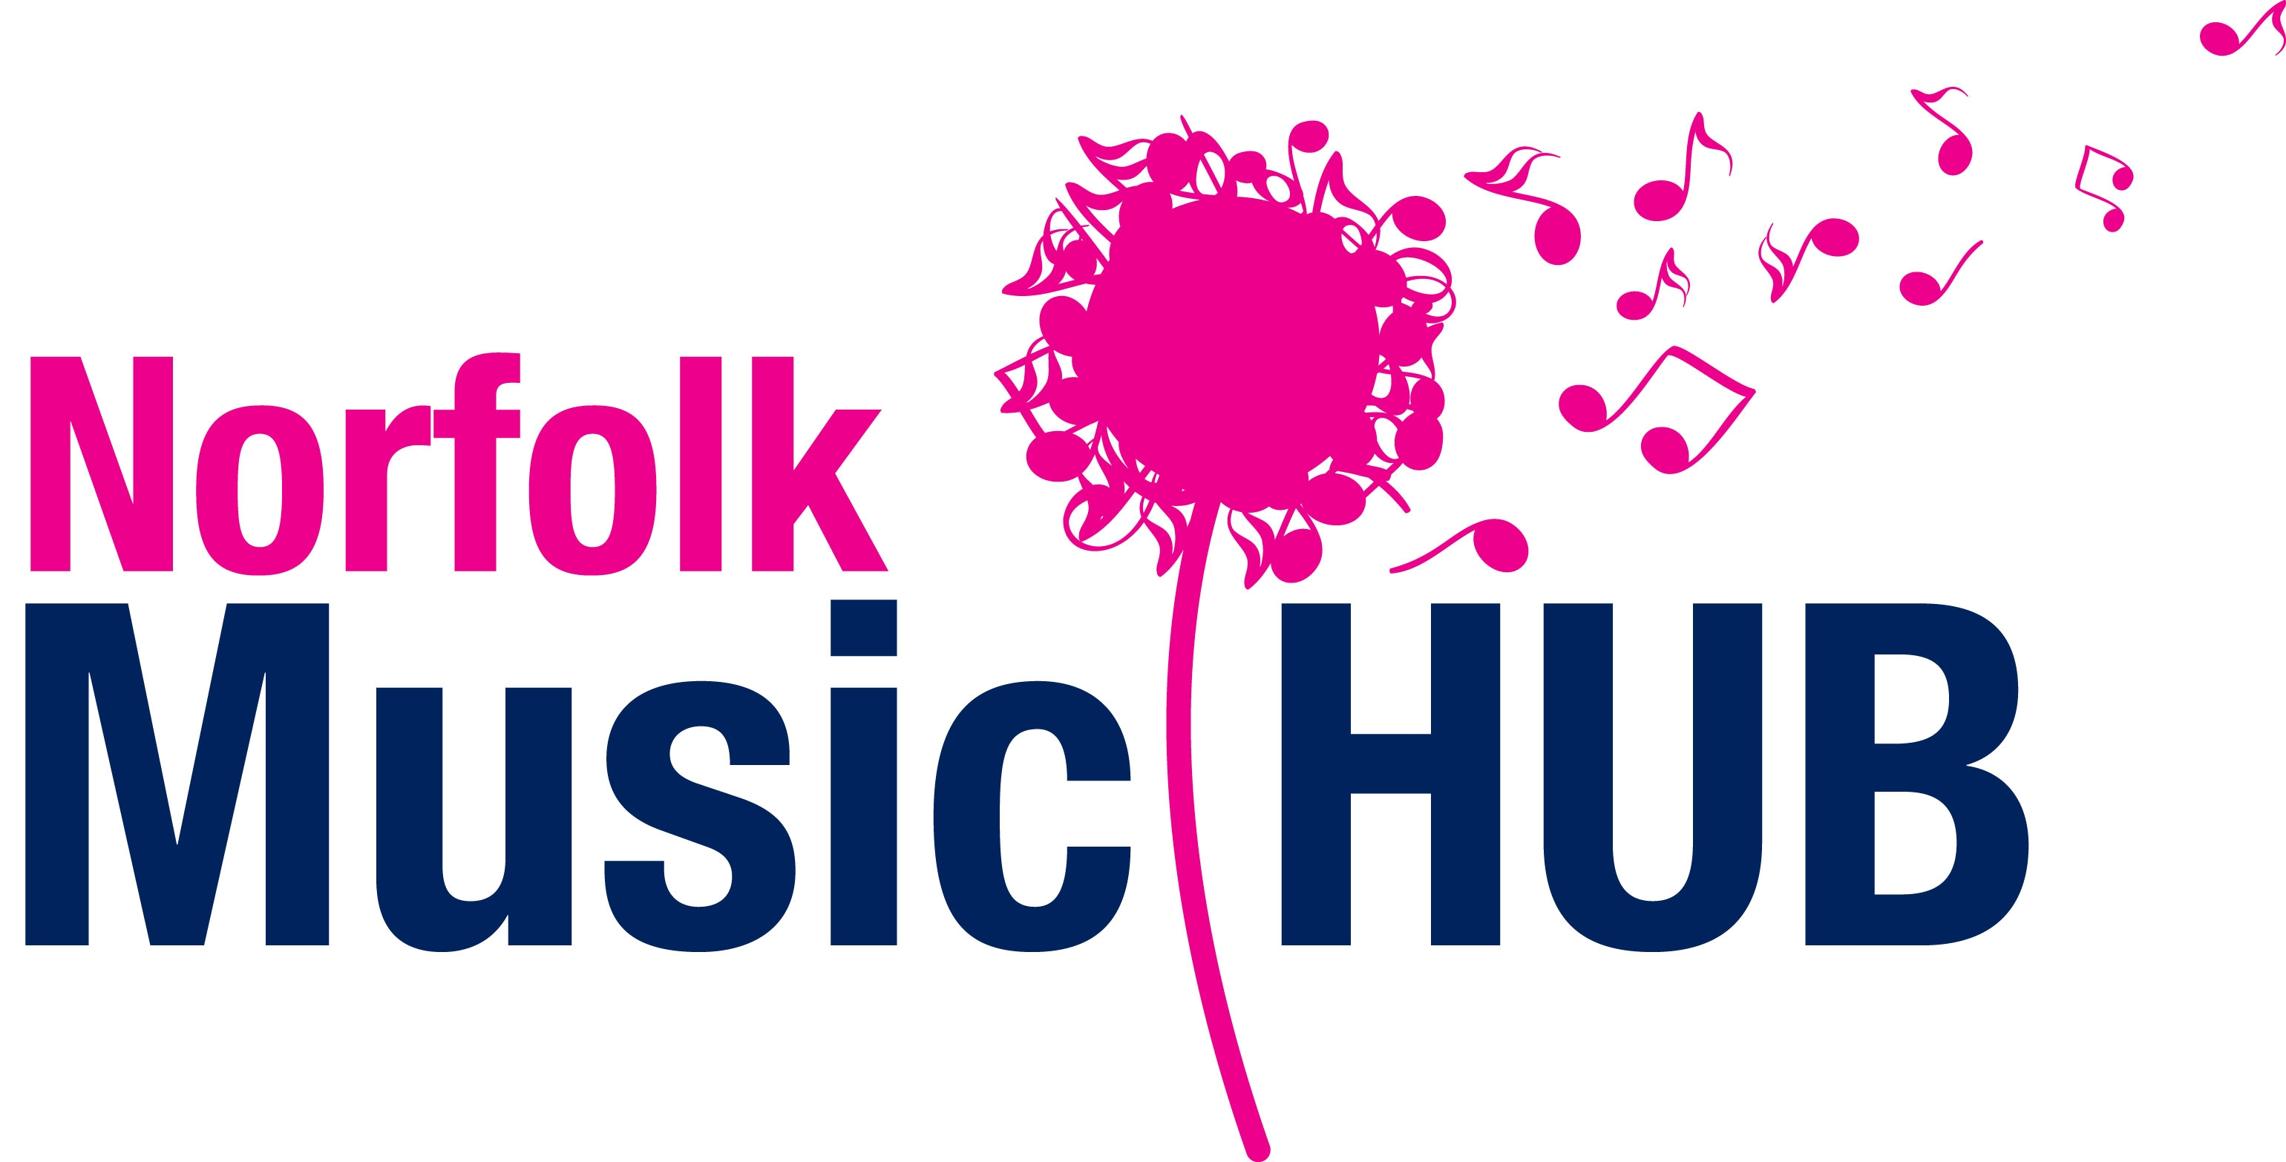 Registered Charity No. 1121851.

......................................................................................
TMP Music Course – 8 August to 10 August 2024 - Application Form

Name ____________________________________________________Age_____________ Male/Female
Address _____________________________________________________________________________
__________________________________________________ Post Code ________________________
E-mail address___________________________________Telephone No. _________________________
Instrument/s _______________________________________ Approx. Standard___________________
Residential / Daily______________
- I enclose a cheque for £ _________ made payable to Thetford Music Project.
- Paid by BACs into account : Thetford Music Project Reference as your surname followed by RES.
Bank: Lloyds .....Sort code : 30-98-97..........Account: 79195763
Reduction of £10 per application for Thetford Music Project members.
Parent/Carer signature _____________________________________ Date_________________ ______

All applicants will be notified by e-mail with further details on acceptance.

Please send form , by 26 th July 2024, to Ann Smith, Director of Thetford Music Project,
Romany Rose, High Rd, Beighton, Norwich, NR13 3LA……………...
OR
Scan completed application form and send by email if paid by BACs
thank you .
Ann
is a Charitable organisation Supported by Registered Charity No. 1121851.

